# Undergraduate Research in Microsystems & Nanotechnology

|  |  |
| --- | --- |
| Duration: | Spring 2014 - Present |
| Group Setting: | Mostly independent with some guidance from faculty advisor and lab manager |
| Responsibilities: | Designing, conducting, and analyzing tests on samples |

My involvement in undergraduate research began when I approached one of my professors about partaking in such an opportunity. She tasked me with refining a procedure for creating nanostructures using a process called nanosphere lithography. After working on this project for a year with encouraging results, I will be changing my focus to the more difficult task of creating graphene transistors.

**My research with nanosphere lithography was selected to represent the University of Wisconsin – Platteville at an event called “Posters in the Rotunda” in April of 2015 at the state capital building. At this event I will have the opportunity to show my research to state legislators and talk to them about the benefits of undergraduate research.**

# Nanosphere Lithography

|  |  |
| --- | --- |
| **Project Length:** | 1 Year |
| **Period:** | Spring – Fall 2014 |
|  |  |

The basic steps for this type of lithography are as follows.

* Clean substrate
* Spin coat 1 µm (or smaller) spheres on surface of substrate
* Deposit metal over substrate using the spheres as a mask
* 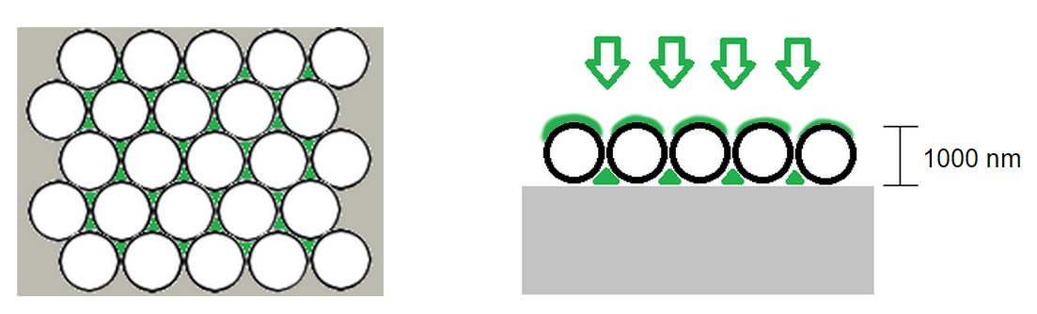Remove spheres from surface to expose nanostructures

Shows illustration of sphere arrays on surface, and the areas where the deposited metal (green) adheres to the substrate (left). A cross-section view of metal deposition is shown on the right.

E:\#Andy\MSNT Research\Fall 2014\Random\3d2.tifShows a scanning electron microscope image of the boundary of where spheres were removed. The nanostructures that are left are approximately 200 nm across.

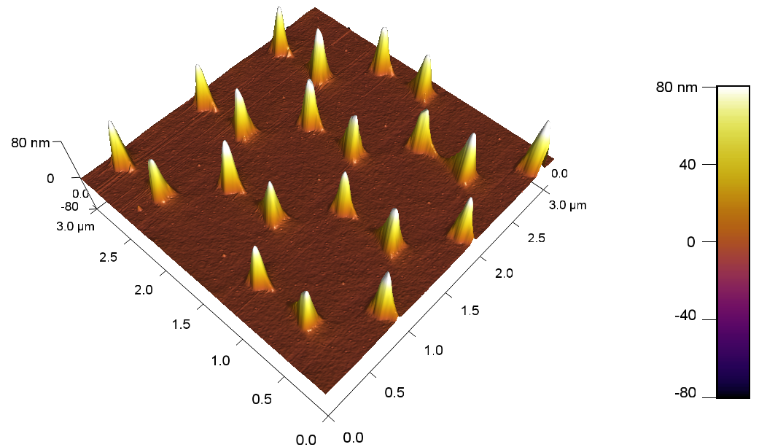Shows an atomic force microscope image of several nanostructures.

# Boy Scouts of America

|  |  |
| --- | --- |
| Position: | Senior Patrol leader,  Assistant Senior Patrol Leader,  Instructor |
| Duration: | 2001 - 2012 |
| Group Setting: | Mostly worked in teams and small groups |

# Eagle Scout Service Project

|  |  |
| --- | --- |
| **Project Length:** | 5 Months |
| **Period:** | Spring 2010 |

For my Eagle Scout project, a group of volunteers and I built a 33 ft long ladder bridge over a small ravine at my local mountain biking trails. I designed the bridge in SolidWorks, raised the needed capitol, and then lead a team to construct and install the bridge at the site. Two bridge sections of approximately 15 ft each and were mounted on top of cast concrete footings weighing approximately 1200 lbs. In total, the project took 148 man-hours of effort from volunteers and myself.

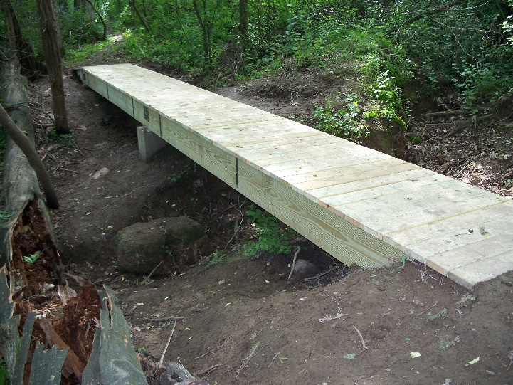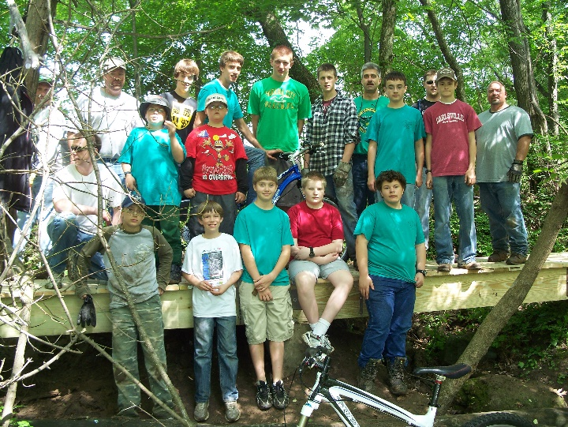

Shows images of the bridge and the team the helped me complete the project.

# Appendix

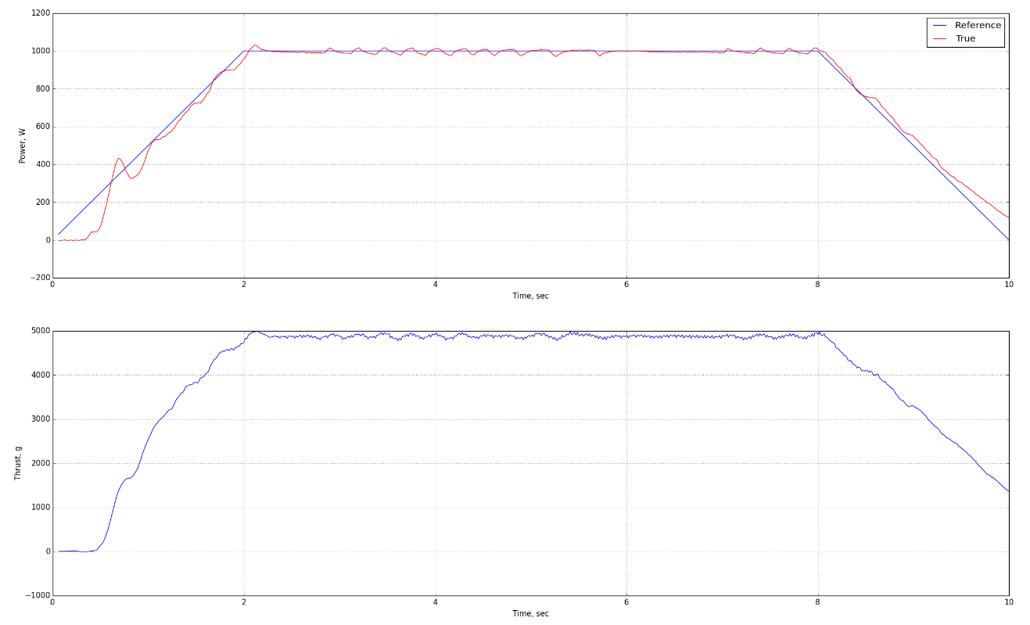

Image of the graphs that are generated by the SAE test stand.